# **Department of Computer Science and Engineering Islamic University of Technology (IUT)** A subsidiary organ of OIC

# **Laboratory Report**

# CSE 4412 : Data Communication and Networking Lab

## 

|  |  |
| --- | --- |
| **Name** | **: Chowdhury Ashfaq** |
| **Student ID** | **: 200042123** |
| **Section** | **: A** |
| **Semester** | **: 4th** |
| **Academic Year** | **: 2022** |
| **Date of Submission** | **: 24/1/23** |
| **Lab No** | **: 4** |

### **Title:** Observation of ARP events and lecture on Logical Addressing.

### **Objective**:

1. Understand how the physical address of a node in the same network is found when the source only knows the logical address.
2. Understand the necessity of hierarchical addressing compared to flat addressing.
3. Understand classful addressing of IPv4 Addressing.
4. Understand the subnet mask.

### **Diagram of the experiment:**

First picture shows the environment or the connection among the PCs. Next the event list is provided after we started simulation and pinged device with IP address 192.168.1.7 from 192.168.1.5.

The PDU details have been provided for source(initial), switch, destination and source(final) all of which are ARP events.

Lastly the picture of command prompt of PC with IP address 192.168.1.5 have been given where we can see the ARP list before and after pinging.

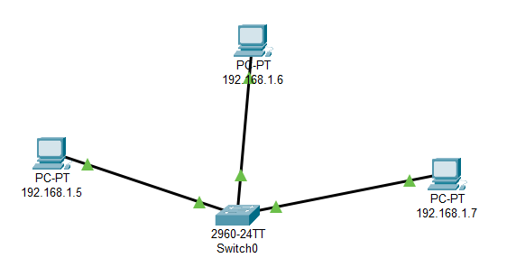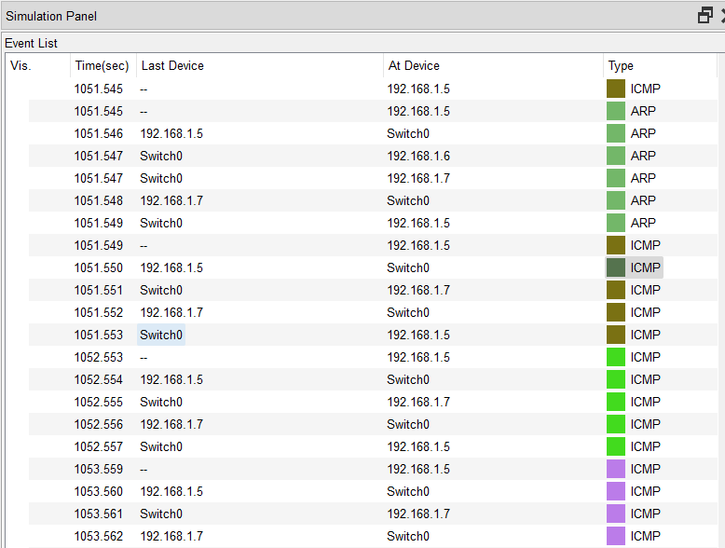

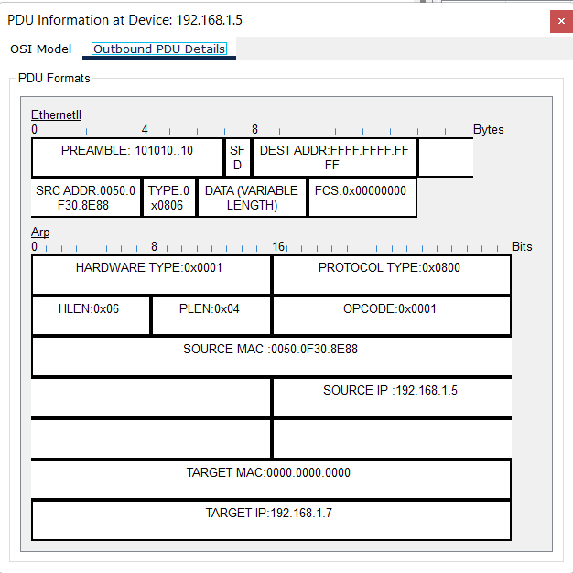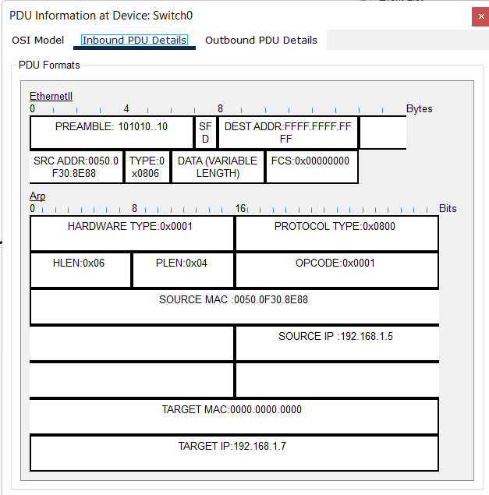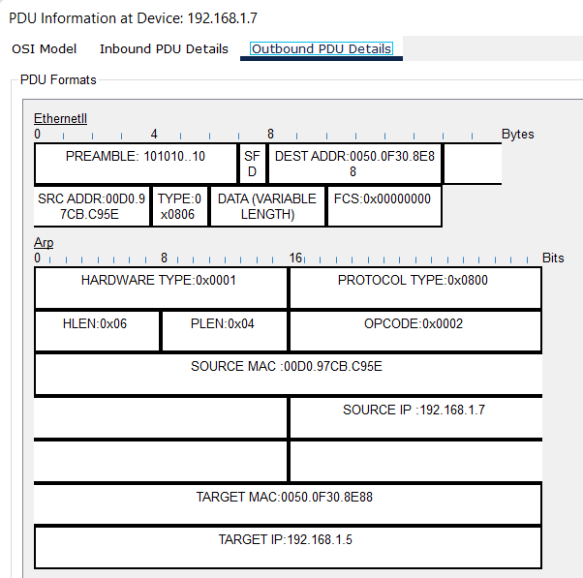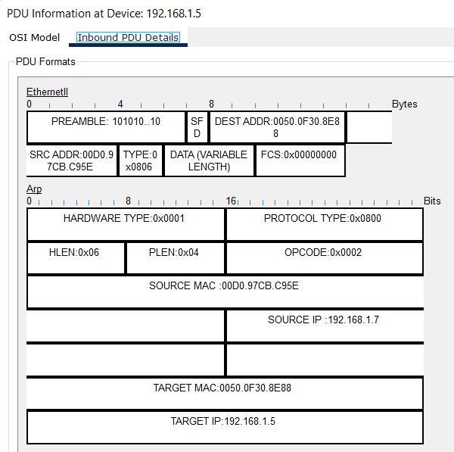

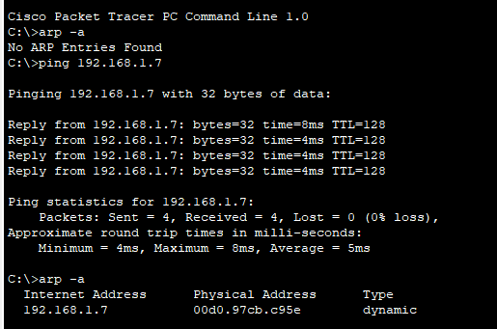

### **Experiment Set Up Description:**

We took 3 PC’s and connected each of them with a switch with the help of wire. Then we configured IP address for each of the PC’s which are 192.168.1.5, 192.168.1.6 and 192.168.1.7 respectively.

Then we expand the simulation panel and on the edit filter option we select only ARP and ICMP. After that from PC1 we send a ping request to PC3.

### **Observation**:

* ARP is an address resolution protocol used for obtaining MAC address with the help of IP address which is required to communicate with other devices in a network.
* If source doesn’t know the MAC address of the destination then it sends ARP request packet to the switch/hub which then forwards it to other devices that are on that network but only the desired destination accepts the packet and sends response ARP request packet to the switch/hub which then reaches the source.
* Once a device establishes connection with another then the ARP table is updated with the MAC address.
* We can check ARP table of a device with ‘arp -a’ command.
* ARP table of a device can be deleted by ‘arp -d’ command.

### **Challenges:**

* Knowing how to observe ARP event.

### **Answer the Following Questions**

1. What is flat addressing and hierarchical addressing? Why is IPv4 address a hierarchical addressing?

-> A general form of location identification that is made up of several levels to accommodate more numbers. It makes easier to route messages from source to destination.

IPv4 uses hierarchical addressing scheme. The four parts of the IP address are configured with the help of this system.

1. What are the ranges of ip addresses in class A, B, C.

-> Range of IP addresses in class A,B,C are:

A: (0-127).(0-255).(0-255).(0-255)

B: (128-191).(0-255).(0-255).(0-255)

C: (192-223).(0-255).(0-255).(0-255)

1. What is a subnet mask? How to determine the network address and broadcast address of a network from an IP address and subnet mask? What are the default subnet mask of a class A, B, C network.

->Subnet Mask is a 4 partitioned dotted value which would be same for a particular network used for logical subdivision of an IP address.

Network address can be determined by AND operation of IP address and Subnet Mask. The first value of the range of hosts is the network address.

Broadcast address is last address of the range of hosts that can be found after AND operation of IP address and subnet mask.

### 